1. **Gen Bằng Eclipse**
2. Download phiên bản MySql connector mới nhất

<https://dev.mysql.com/downloads/connector/j/> (download đúng version 5.1.48)

1. Run -> Run Configurations... -> Classpath -> Add external JAR 🡪 file mysql-connector-

java-5.1.0-bin trong folder giải nén ở B1

<https://stackoverflow.com/questions/19319712/hibernate-classnotfoundexception-com-mysql-jdbc-driver>

1. Nếu không tìm được connection (như bên dưới) thì tạo bằng JPA (ở mục 3) để ra được

hình bên dưới

chọn đúng version 5.1.48 (đã download ở trên)

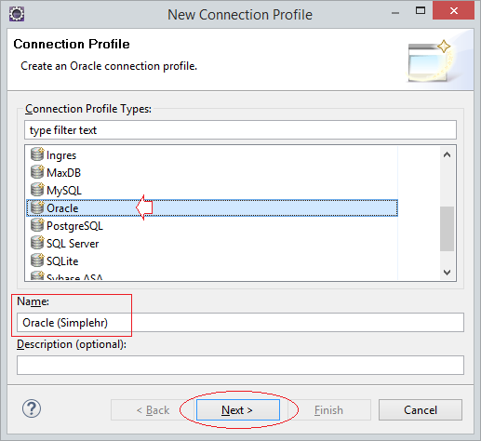

1. Làm theo hướng dẫn https://o7planning.org/en/10125/using-hibernate-tools-generate-entity-classes-from-tables

Tới bước **New Driver Definition,** trong tab **JAR List** remove file jar default đi và add file java-5.1.48-bin trong folder giải nén ở B1 vào

* **Reference**

https://o7planning.org/en/10125/using-hibernate-tools-generate-entity-classes-from-tables

Setup: <https://www.youtube.com/watch?v=KO_IdJbSJkI>

<https://www.codejava.net/frameworks/hibernate/java-hibernate-reverse-engineering-tutorial-with-eclipse-and-mysql?fbclid=IwAR2hv-RpuBkNIxjHEt4Bv0iT0pNmXOtFyj9sNOED0PRVecgMVXU7ed1XS-8>

1. **Gen bằng NetBean**

<https://vovanhai.wordpress.com/java/l%E1%BA%ADp-trinh-java-nang-cao/jpa-java-persistence-api/lam-vi%E1%BB%87c-v%E1%BB%9Bi-jpa-trong-netbean-61/>

Khi NetBean gen ra Entity thì xóa các phần sau

* @XmlTransient
* @XmlRootElement
* @NamedQueries
* gen lại constraint table (NetBean không gen)

Có thể dùng Eclipse

* **Note**: Với các Table đặc biệt thì để
* MySql: `Table`
* Sql Server [Table]